Hazardous gas detection system

Name- Aditya Kumar, Aman Kumar, Ankit Shukla, M. Ramaiah

Roll no. 21781A04L8, 21781A04L9, 21781A04M1, 22785A0416.

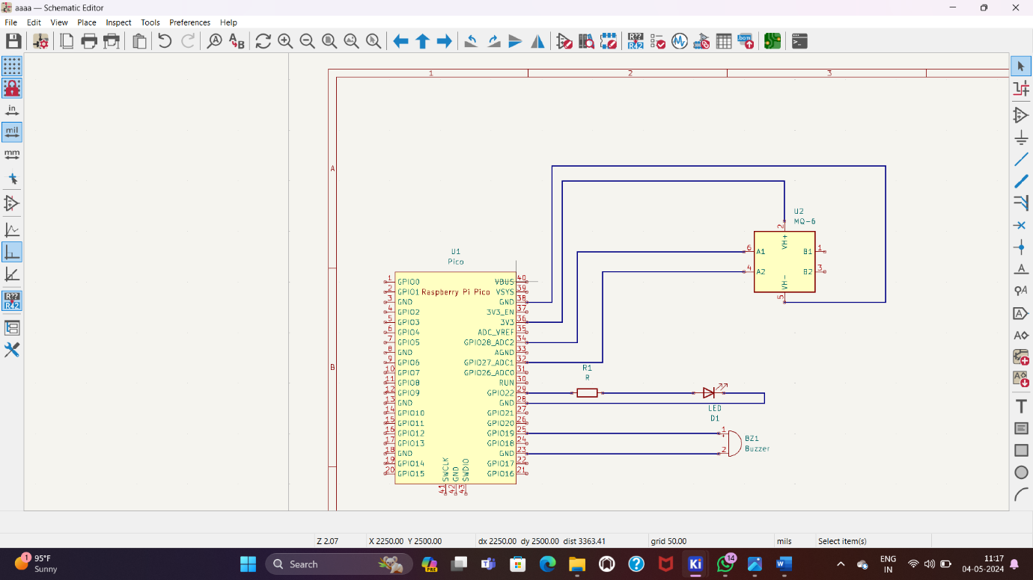

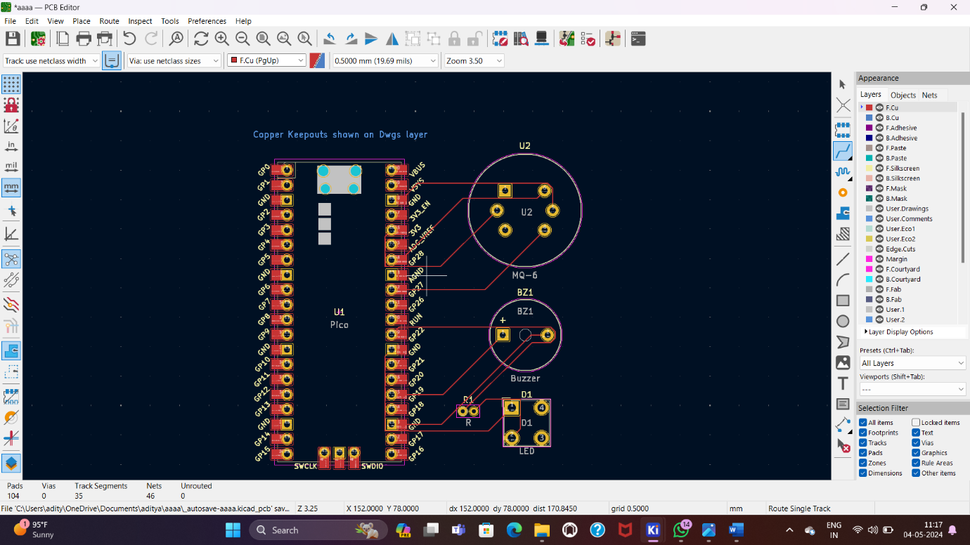

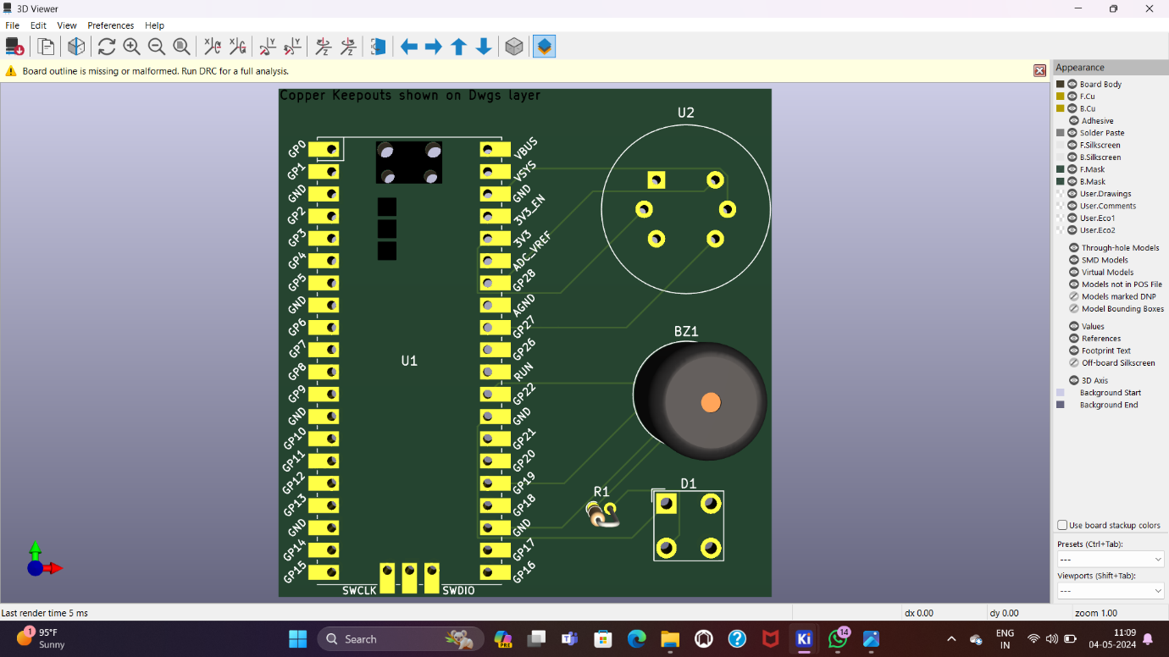

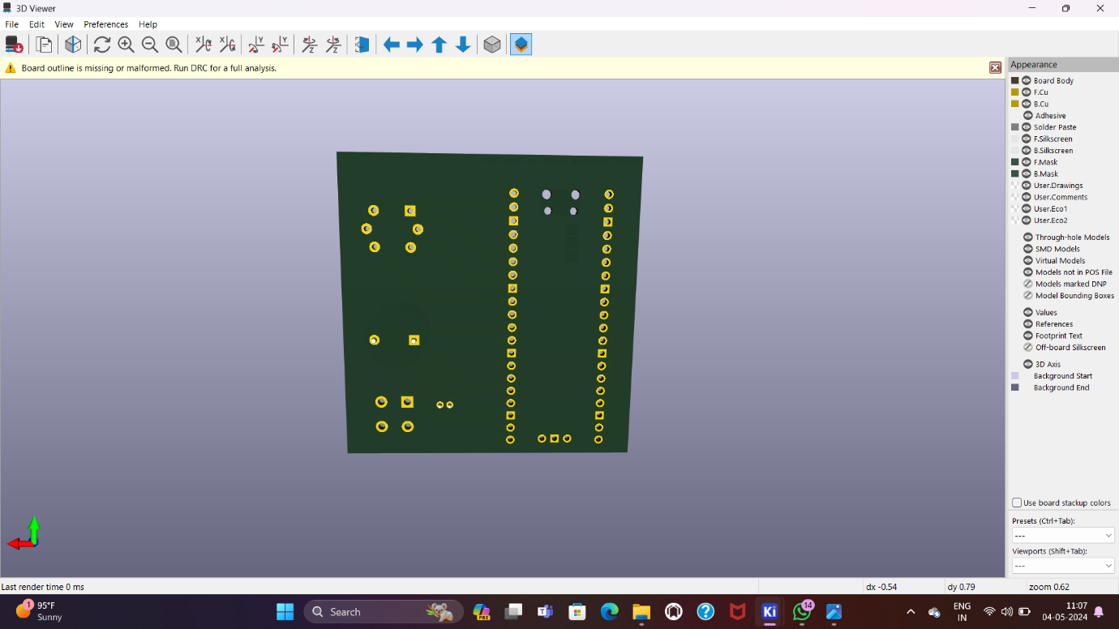

**PROGRAM**

**import machine**

**import time**

**Define pin numbers**

**PIR PIN machine. Pin(27, machine. Pin.IN)**

**BUZZER PIN machine. Pin(6, machine. Pin.OUT)**

**# Function to activate the buzzer**

**def activate_buzzer():**

**BUZZER PIN.on() #Turn buzzer on**

**time.sleep(0.5) #Keep buzzer on for 8.5 seconds**

**BUZZER PIN.off() #Turn buzzer off**

**# Main loop to detect motion**

**while True:**

**if PIR PIN.value(): #PIR sensor detects motion**

**print("Motion detected!")**

**activate_buzzer() # Activate the buzzer**

**time.sleep(0.2) #Small delay to debounce and save CPU**

**OUTPUT:-**

Motion detected

Motion detected

Motion detected

Motion detected

Motion detected

Motion detected

Motion detected

Motion detected

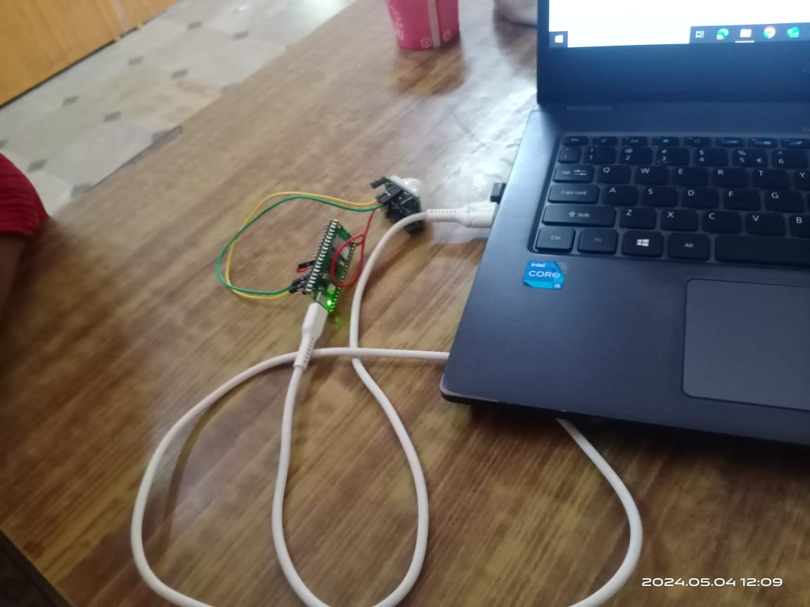

NUCLEAR RADITION DETECTION

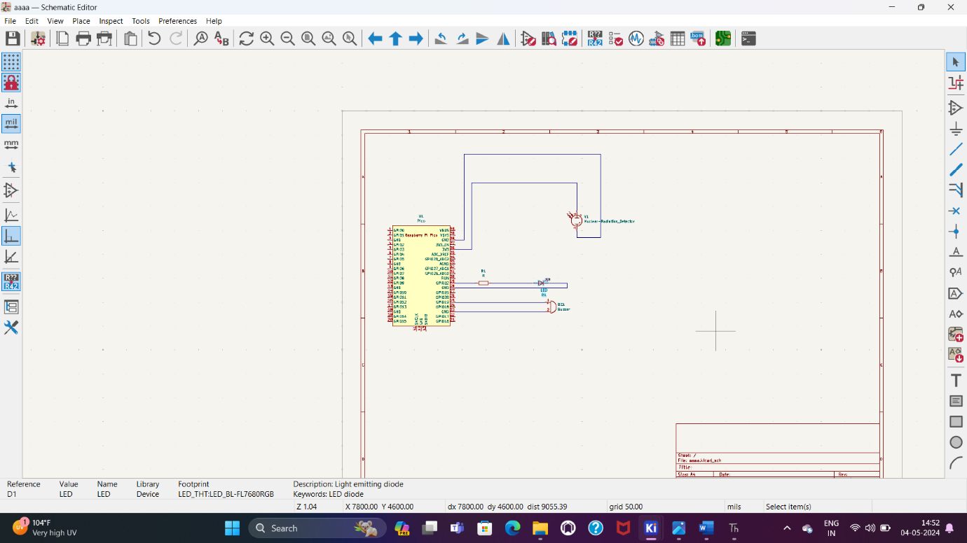

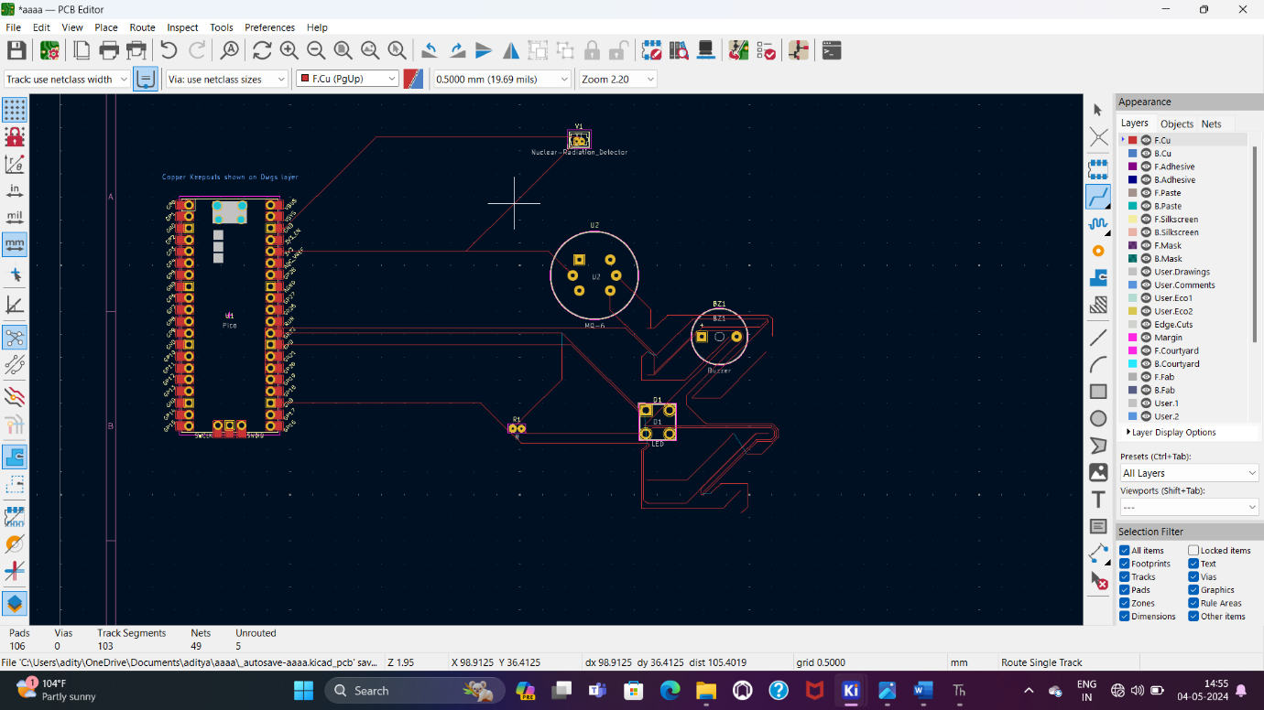

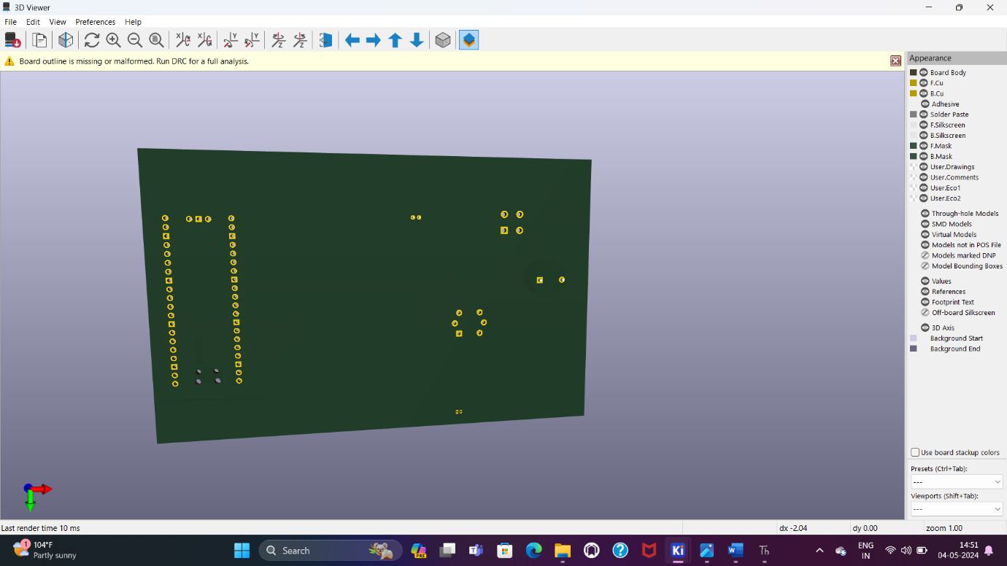

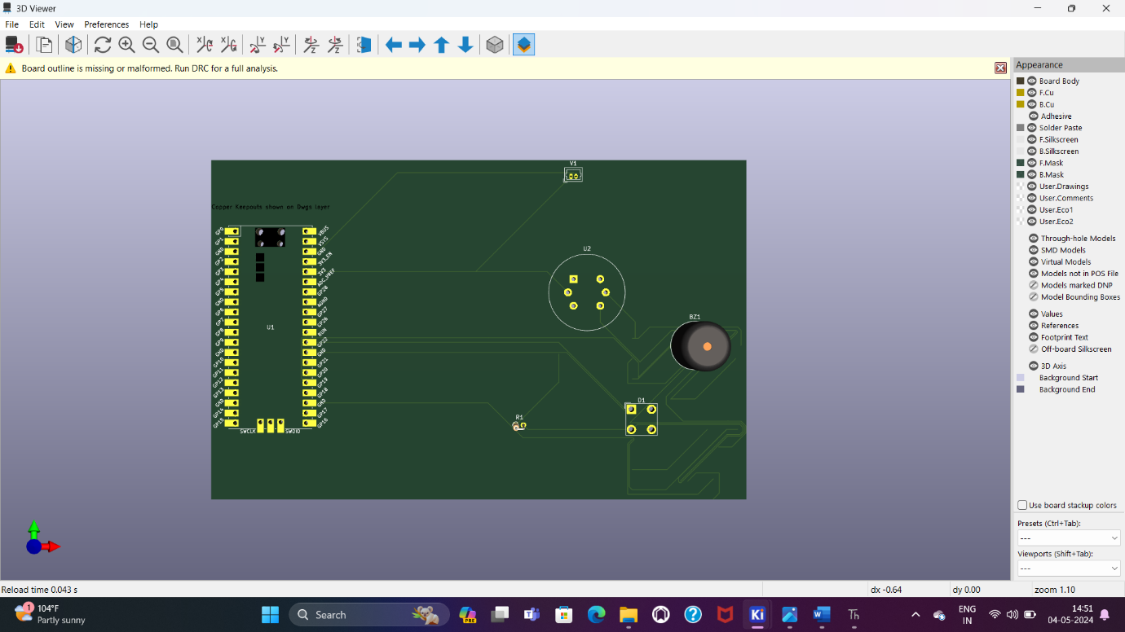

CONCLUSION:-

For a conclusion on a hazards gas detector, you could summarize its importance in safeguarding against dangerous gas leaks, emphasizing its role in protecting lives, property, and the environment. Highlight its ability to provide early warnings, allowing for timely response and mitigation measures. Additionally, you might mention the importance of regular maintenance and calibration to ensure accurate and reliable performance. Overall, a hazards gas detector is a critical tool in industrial, commercial, and residential settings for maintaining safety and preventing accidents related to gas leaks.